User Guide for Online Exam Portal

September 2021

**Instructions:**

* Change everything that is in brackets []
* Add your practical project content to the document
* Make sure that your Table of Content is updated
* Update the document revision table
* Complete all the Process and Process Steps for your practical project in this document

Document Revisions

|  |  |  |
| --- | --- | --- |
| Date | Version Number | Document Changes |
| XX/XX/20XX | 0.1 | Initial Draft |
|  |  |  |
|  |  |  |
|  |  |  |
|  |  |  |
|  |  |  |
|  |  |  |
|  |  |  |
|  |  |  |

Contents

1 Introduction 5

1.1 Scope and Purpose [5] 5

1.2 Quick Start Guide [5] 5

2 Schedule Exam 6

2.1 Steps of scheduling exam 6

3 Start exam process. 7

3.1 Steps of Process Start exam 7

4 Index 8

# Introduction

## Scope and Purpose [5]

* The Online Exam Portal is a portal that will be hosted online for users access it during the exams. This is a file upload exam portal which is simple and efficient to use.
* The portal has a page where students have to register for the modules that they will be writing. After registering students will receive a link to the exam portal for their specific modules. The admin or lectures will be able find how much the student has scored.
* The main objective of this guide is to give users a guide on how to use the system.

## Quick Start Guide [5]

**Provide an overview of the functionality of the practical project and how the user will interact with the practical project.**

At first, the portal will display the login screen where users will login to the portal using it. Students must login using their mylife email address and admin will login using their username and password. If the user is login as a student, they will be redirected to student site page. The student site page consists of a horizontal menu and a dropdown list of the modules which student has enrolled for. Student should choose the module they are writing and click continue. Thereafter, the next page is the exam page which displays information about the module that student has selected. If the current date is the exam date for that specific module, then the page will enable students to start writing the exam.

If the user has logged in as admin, they will be redirected to admin site page. The admin site page consists of a horizontal menu and the list of exams for the current semester. The admin can also be able to set exam, edit exam, and schedule exam.

# Add New Exam

On this process, admin should schedule exam for the current semester. The admin will select the date and time on which the exam should written.

## Steps of adding new exam

Steps for adding new exam:

1. On the web browser, type in the url of the portal.
2. Login using the username and password.
3. From the horizontal menu, click on schedule exam. The schedule exam page should look like the below example.

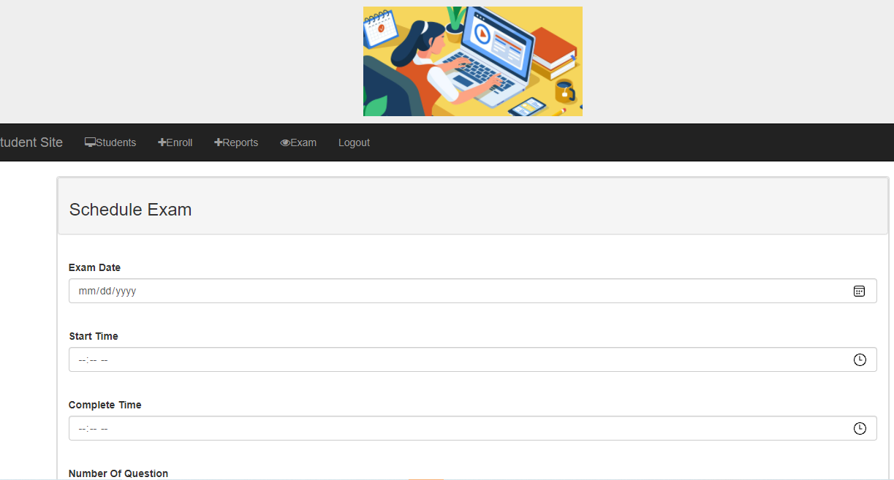

4. Click on the submit button after filling in the form.

# Start exam process.

**Provide an overview of the Process AAA in the practical project …**

On the process of starting an exam, student should login with mylife email address. Therefore student site page will display a dropdown list with the modules that the student has registered for.

## Steps of Process Start exam

Steps for Process Starting exam:

1. On the web browser, type in the url of the portal.
2. Login using the username and password.
3. The student site will look similar the below image.

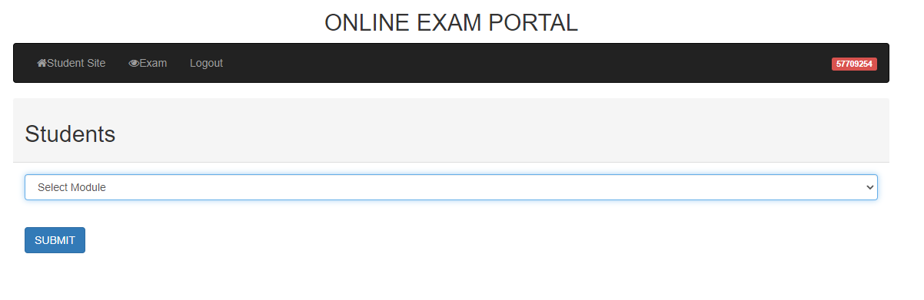

1. Select the module to write and click continue
2. The next page should look like the one below.

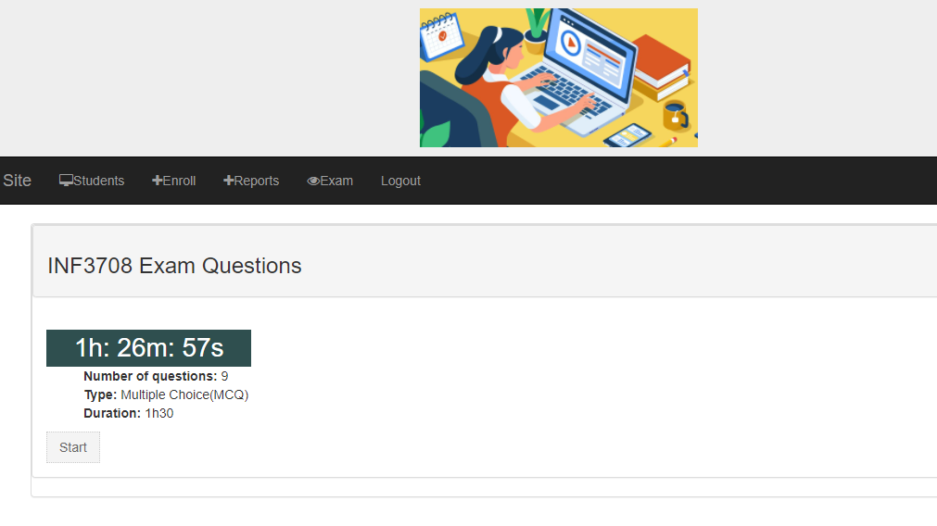

1. Click on start button

# Index

Depending on the size or complexity of the final document, consider pulling together an index to assist the using in location specific information.